**Sri Lanka Institute of Information Technology**

**IE2062 - Web Security**

**Final Assignment**

**Bug Bounty Report 07**

**Name:** Peiris W.S.S.N

**Registration Number:** IT23227286

Contents

1. Introduction 3

2. Reconnaissance 4

3. Vulnerability 5

4. Vulnerability description 5

5. Affected Components 6

6. Impact Assessment 6

7. Steps to reproduce 7

8. Proof of concept 7

9. Proposed mitigation or fix 7

# Introduction

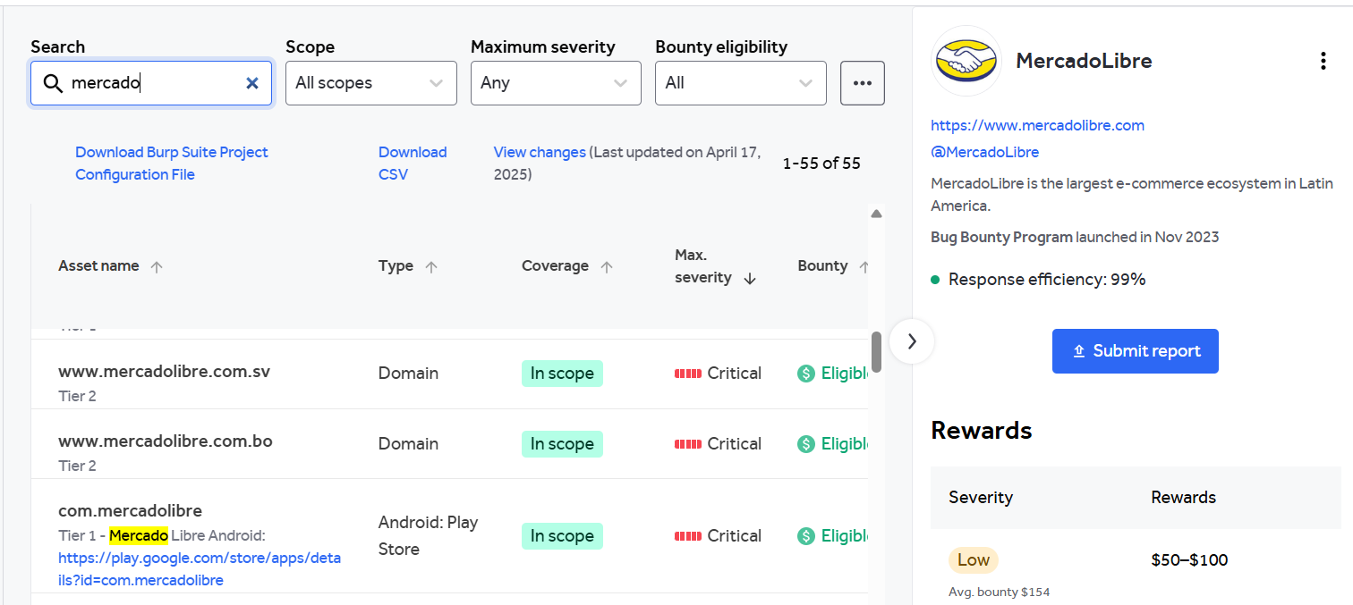

**Website:** <https://www.mercadolibre.com.bo/>

**Listed by:** MercadoLibre

# Reconnaissance

* **Subdomain enumeration using Amass**

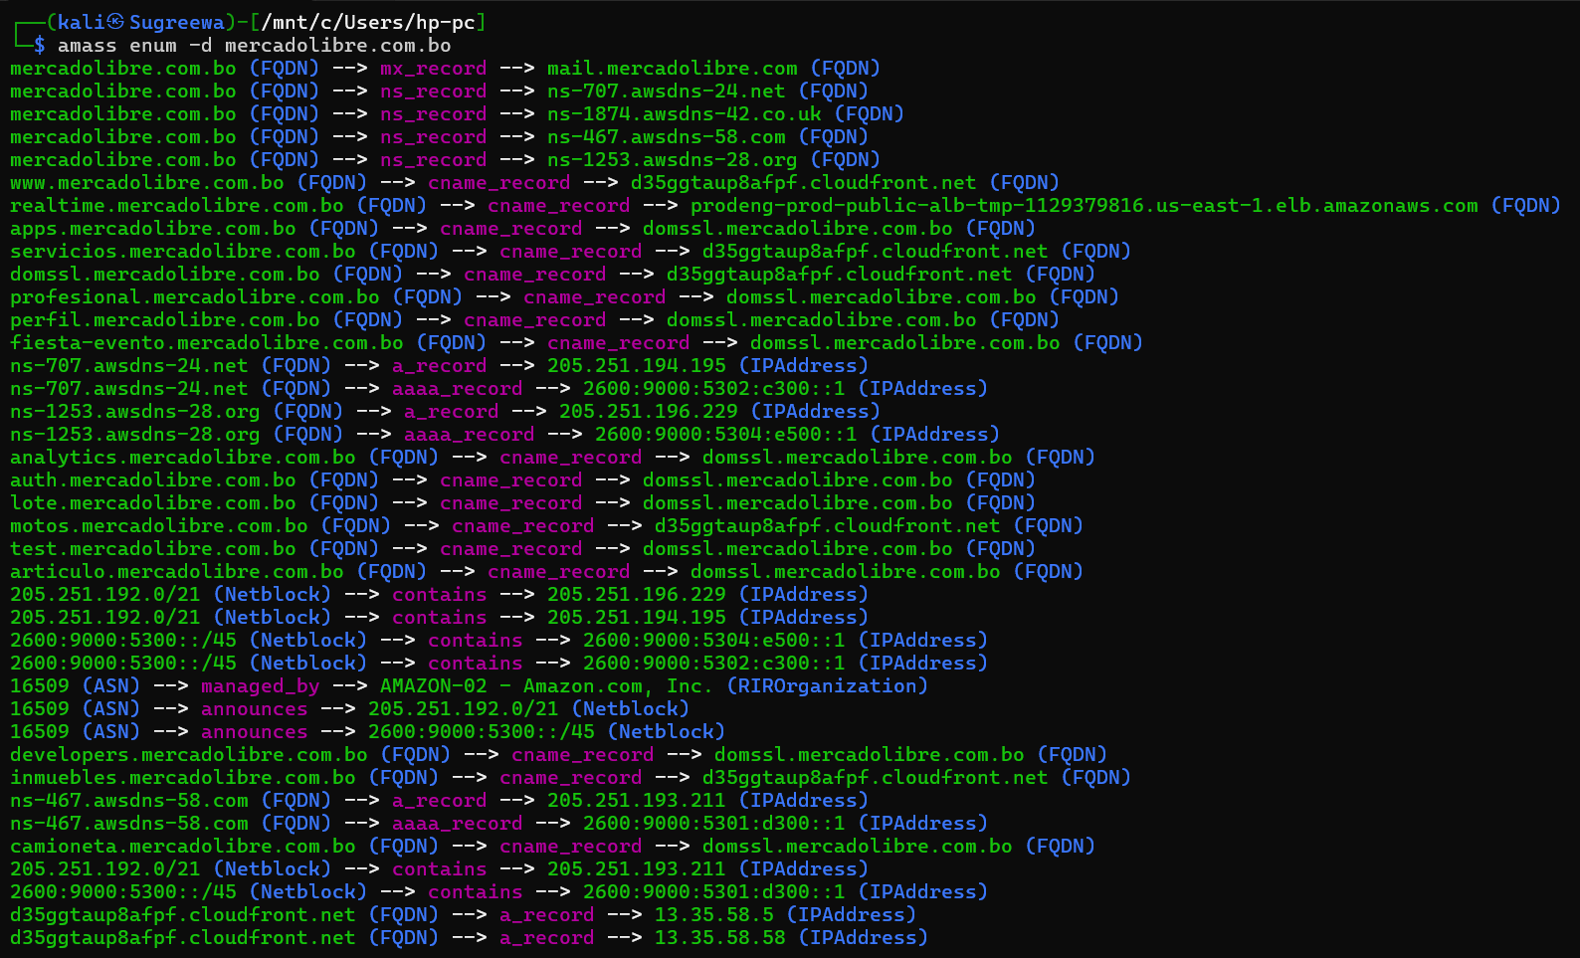

* **Firewall Detection**

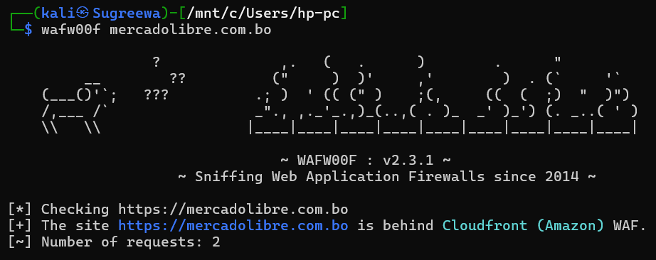

* **Nmap Scan**

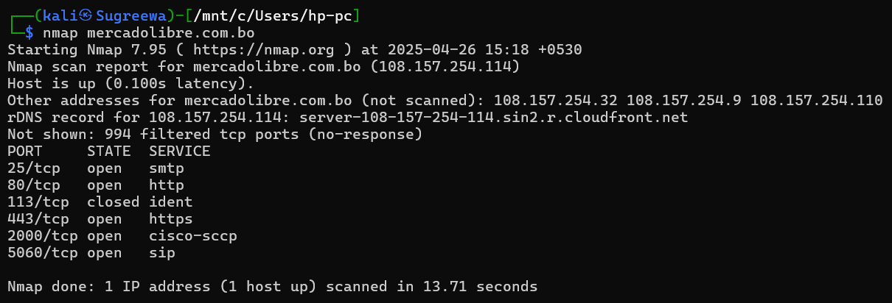

# Vulnerability

* **Cross-Domain Misconfiguration**

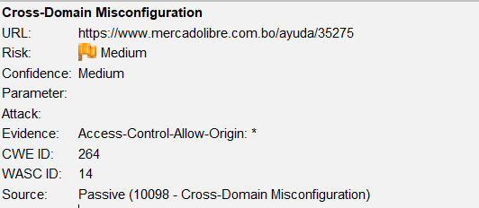

# Vulnerability description

Web browser data loading may be possible, due to a Cross Origin Resource Sharing (CORS) misconfiguration on the web server.

1. Affected Components

* **Component:** HTTP Response Header → Access-Control-Allow-Origin
* **Value Detected:** *
* **Affected Endpoints:** Any API or web resource returning this header (typically GET requests to public APIs or JSON endpoints)
* **Context:** Applies to unauthenticated resources exposed via cross-origin GET requests

# Impact Assessment

* **Risk Level:** Medium
* **Potential Impacts:**
  + Unauthorized access to publicly available (but sensitive) data
  + Abuse of endpoints intended for internal or IP-restricted use
  + May aid **data harvesting**, **fingerprinting**, or **API abuse**
  + Lower risk for authenticated endpoints (browsers block responses from credentialed cross-origin requests if * is used)

# Steps to reproduce

* Open your browser’s **DevTools** or use **cURL**, **Burp**, or **Postman**.
* Send a GET request to a known unauthenticated API endpoint.
* Inspect the response headers.
* Confirm the presence of: Access-Control-Allow-Origin: *

# Proof of concept

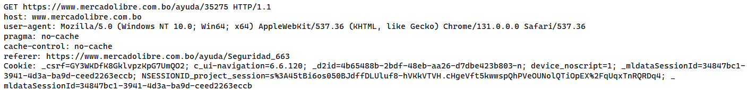

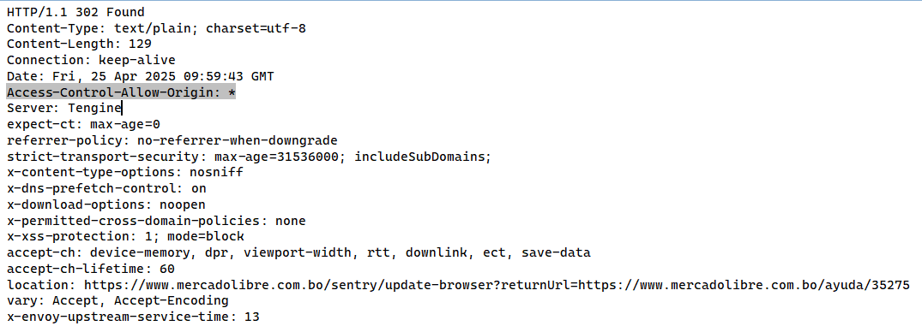

# Proposed mitigation or fix

Ensure that sensitive data is not available in an unauthenticated manner (using IP address white-listing, for instance).

Configure the "Access-Control-Allow-Origin" HTTP header to a more restrictive set of domains, or remove all CORS headers entirely, to allow the web browser to enforce the Same Origin Policy (SOP) in a more restrictive manner.